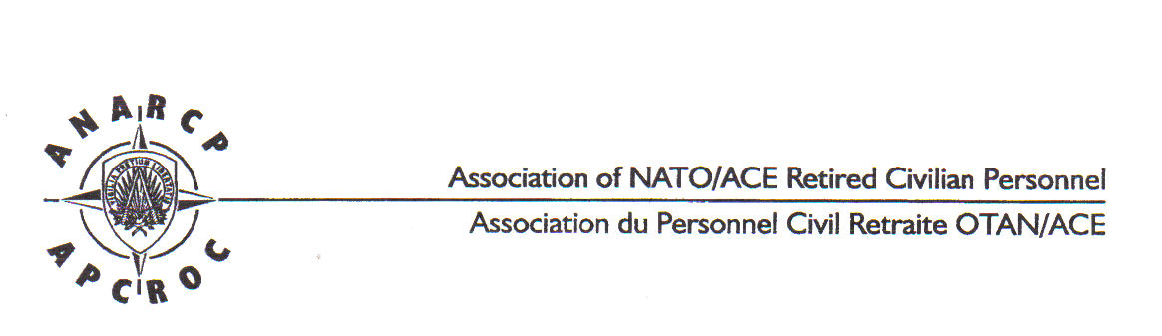
AUTHORISATION TO DEDUCT SUBSCRIPTION
(Copy to be completed and emailed to: anarcp@cnrcsa.nato.int)

I, the undersigned
Name : ____________ ___________________________________________
First Name(s) : _________________________________________________
Full address : __________________________________________________
__________________________________________________

being in receipt of a pension paid by NATO, under file number (1) __________
confirm that I am a member of the Association of NATO/ACE Retired Civilian
personnel (ANARCP) and agree that my subscription to this Association be
deducted once a year from my pension as from December 2023, and paid to
ANARCP.
This authorization is renewable by tacit reconduction. It may be terminated at
three months’ notice.

Done at : ________ _____________ on : ____________________________

Signature : _____________________________________________________
(Please write in your own hand "Read and Approved" before your signature).
…………………………………………………………………………………
(l)This number is shown on your pension slip. If you did not yet receive a pension slip, thank you for providing us with that number on the earliest occasion.

Per coloro che preferiscono effettuare il pagamento con bonifico bancario, da farsi entro il mese di dicembre dell’anno precedente, il versamento della quota annuale (attualmente 20 euro) va fatto sul conto:
Coordinate bancarie:
BNP PARIBAS FORTIS
IBAN: BE57 2700 4624 7835
BIC: GEBABEBB
Name: APCROC - ANARCP
7010 - SHAPE Belgium

Nelle motivazioni indicare il nominativo, il numero di tessera ANARCP e l’anno per il quale pagate. Se non ricordate il Vostro numero di iscrizione contattate il NatRep.
Dopo aver effettuato il bonifico meglio informare il segretario dell'ANARCP (anarcp@cnrcsa.nato.int ) e il rappresentante nazionale.

